PRACTICAL – 1

Creating a AWS account :-
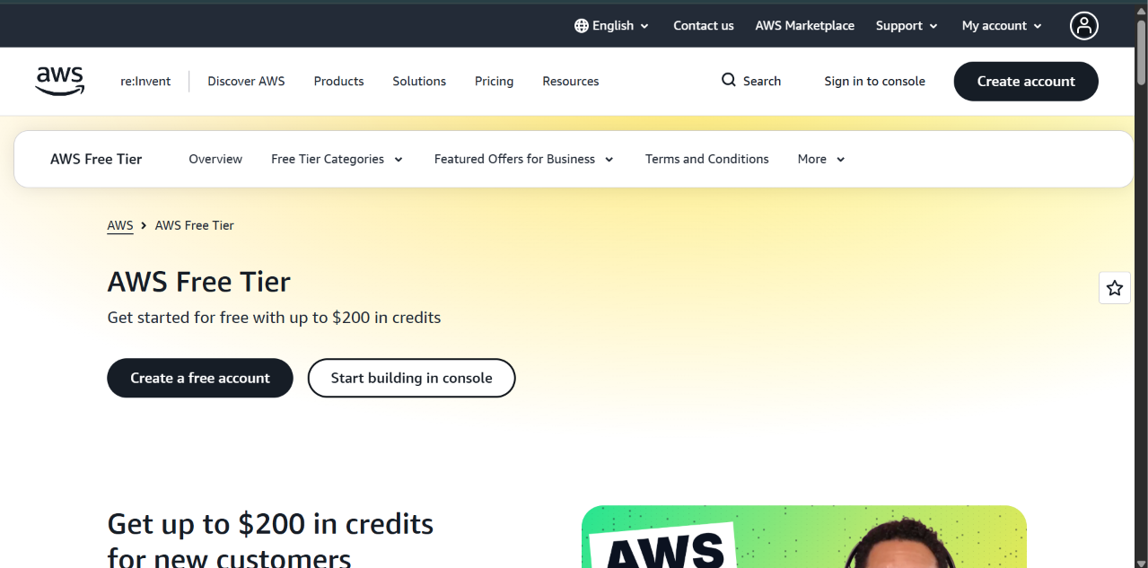
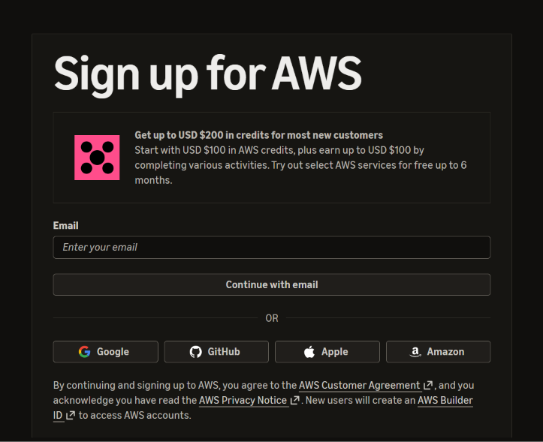
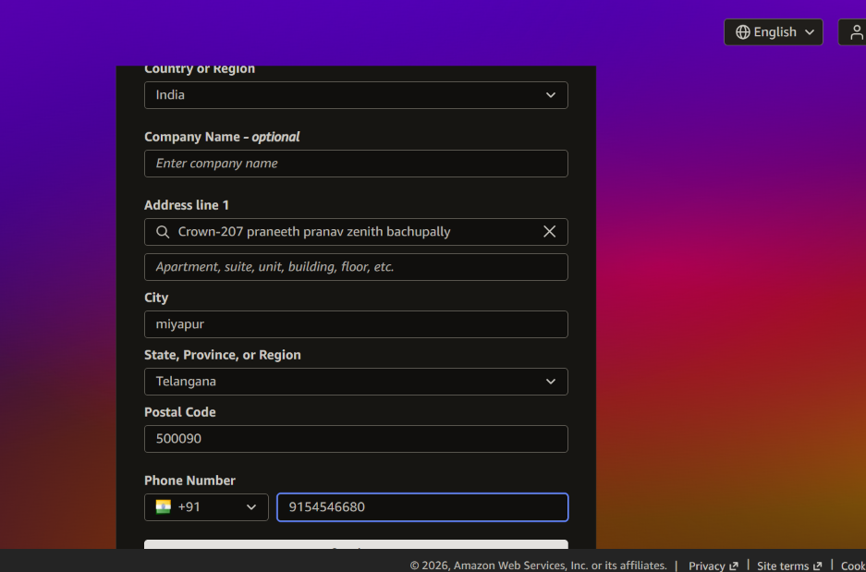
AWS Account Setup
1. Open the AWS website and navigate to the AWS Console Login/Sign Up page.
2. Click on Create Account and enter the required email address and account details.
3. Verify the email address using the verification code received.
4. Create and confirm a secure password.
5. Select the Free Plan during account setup.
6. Enter the required contact information, including name, address, and phone number.
7. Provide the necessary billing information to complete registration.
8. Log in to the AWS Management Console and access the AWS Dashboard.
9. Enable Multi-Factor Authentication (MFA) for additional account security.

